Applications of Derivatives: Cubic Curve
EM1 · 10 marks

Question
For the curve $y=x^{3}−3x$, the sketch below is provided for visualisation only and is not to scale.
(a) Classify all stationary points of the curve, giving each point as a coordinate. [5 marks]
(b) Determine the coordinate of the point of inflection. [2 marks]
(c) Find the equation of the tangent to the curve at $x=2$. [3 marks]
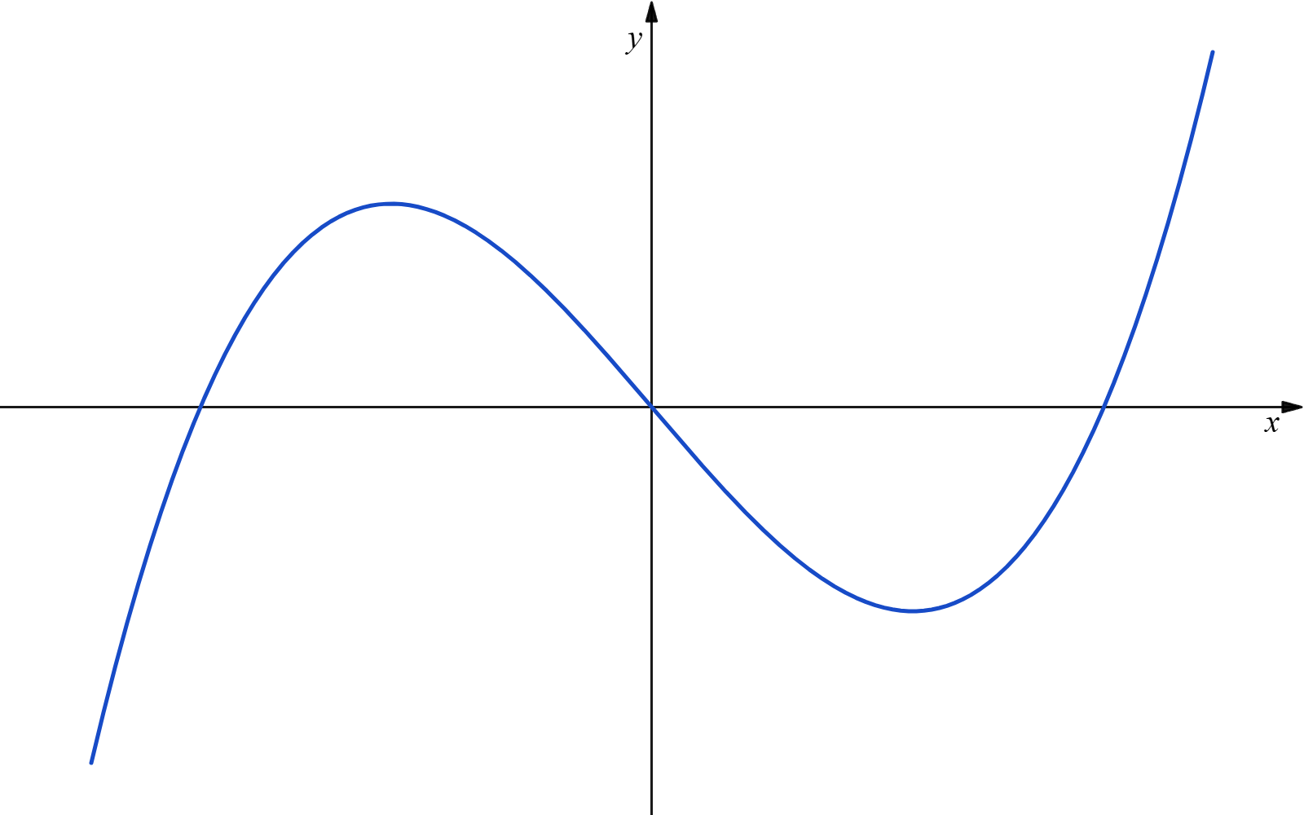
Sketch of $y=x^{3}−3x$ for visualisation, with the coordinate axes labelled.

Main solution
Solution
For $y=x^{3}−3x$,
$\frac{dy}{dx}=3x^{2}−3=3(x−1)(x+1), \frac{d^{2}y}{dx^{2}}=6x.$
For (a), stationary points occur when
$\frac{dy}{dx}=0.$
Thus,
$3(x−1)(x+1)=0,$
so $x=−1$ or $x=1$.
At $x=−1$,
$y=(−1)^{3}−3(−1)=2.$
Also,
$\frac{d^{2}y}{dx^{2}}∣_{x=−1}=−6<0.$
Hence $(−1,2)$ is a relative maximum.
At $x=1$,
$y=1^{3}−3(1)=−2.$
Also,
$\frac{d^{2}y}{dx^{2}}∣_{x=1}=6>0.$
Hence $(1,−2)$ is a relative minimum.
For (b),
$\frac{d^{2}y}{dx^{2}}=6x=0$
gives $x=0$. Since $6x<0$ for $x<0$ and $6x>0$ for $x>0$, the concavity changes at $x=0$. Also,
$y=0^{3}−3(0)=0.$
Therefore, the point of inflection is
$(0,0).$
For (c), when $x=2$,
$y=2^{3}−3(2)=2, \frac{dy}{dx}=3(2)^{2}−3=9.$
The tangent has gradient $9$ and passes through $(2,2)$. Thus,
$y−2=9(x−2),$
so the equation of the tangent is
$\boxed{y=9x−16}.$

Proposed marking allocation
(a): Obtains $\frac{dy}{dx}=3x^{2}−3$ and solves $\frac{dy}{dx}=0$ to obtain $x=−1,1$. [2 marks]
(a): Finds the corresponding coordinates $(−1,2)$ and $(1,−2)$. [1 marks]
(a): Uses $\frac{d^{2}y}{dx^{2}}=6x$ correctly to classify $(−1,2)$ as a relative maximum and $(1,−2)$ as a relative minimum. [2 marks]
(b): Solves $\frac{d^{2}y}{dx^{2}}=0$ to obtain $x=0$ and verifies that the concavity changes there. [1 marks]
(b): Finds the point of inflection as $(0,0)$. [1 marks]
(c): Finds the point on the curve at $x=2$ as $(2,2)$. [1 marks]
(c): Finds the gradient of the tangent at $x=2$ as $9$. [1 marks]
(c): Forms the tangent equation $y=9x−16$. [1 marks]

Reference questions
EXAM AY2025/2026 S2 · A4
EXAM AY2024/2025 S2 · B6(b)
EXAM AY2025/2026 S1 · B6(a)
EXAM AY2025/2026 S1 · A5

